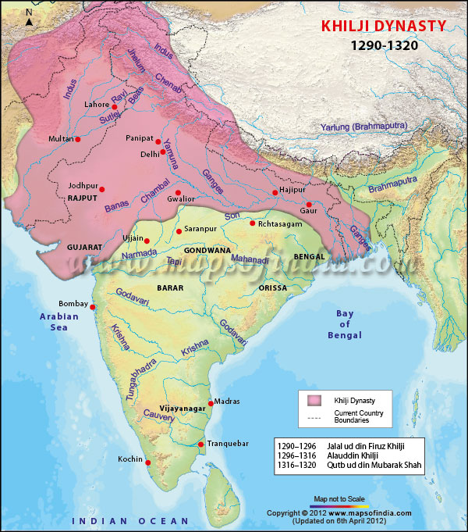

1. Mongol attacks increased on the delhi sultanate during the reign of A.Khalji.
2. This forced him to marshal a very large standing army in Delhi which could not be altered any time in the event of a sudden Mongol attack.
3. But this was a huge administrative and economic challenge for him.
4. The sultan could not have given iqta to all the soldiers and therefore he preferred to give them cash salary.
5. The payment to the huge contingent also meant that Alauddin Khalji also controlled the prices of the commodities as he had to maintain the large army at a minimum cost.
6. He fixed the prices of all commodities from grain to cloth, slaves, cattle etc.
7. He established granaries in Delhi and Rajasthan to collect grains from the grain merchants.
8. A controller of the market(shahna-i-mandi) and intelligence officers( barids) were appointed to implement the market control measures.